**Institute of Technology Tralee**

**Ordinary/Honours BSc. in Computing with Specialism (Group C) - Year 1**

**Continuous Assessment #1**

**Date: 9/11/12**

**Time: 9 – 11 a.m.**

**Introduction to Programming**

**Instructions:** Attempt the following question. You should use the Just BASIC IDE for coding. When you are finished you must print out your code for correction.

**________________________________________________________**

**Q1.**

In order to use an ATM, a customer enters their bank-card into the machine and is then prompted for their PIN. If the PIN supplied by the user does not match the value from the magnetic-strip on the card, the user should be given a suitable error message and the program should immediately terminate.

You can assume for simplicity here that the value initially read from the magnetic strip is stored as an **integer** in the program and its value is the number **1234**.

If the PIN entered by the user matches the value read from the magnetic strip on the card then the ATM program continues by clearing the screen (don’t worry about this part for Java) and giving the user a number of options as follows

1. Make a withdrawal
2. Display balance on screen
3. Exit system

The user should be prompted for their choice and, when the selection has been made, then the program should take the appropriate action as follows:

**“Make a withdrawal”** means that the user will be prompted for the amount they desire and they can withdraw any amount as long as their balance allows it. You can assume in this simplified case that the customer’s **initial balance is always €1000**. If the customer attempts to withdraw beyond their balance, they should receive a suitable warning message and the program should immediately terminate. If the withdrawal amount is valid then they should “receive” this amount (just a suitable message to screen will suffice here to indicate a successful withdrawal) and this amount should be subtracted from their current balance, which should then be displayed.

**“Display balance on screen”** means that the user’s current balance should be displayed to the screen. In our simplified case, the opening balance is always €1000 so this is the value that will always be displayed in our case.

**“Exit system”** simply means that the program should perform no processing whatsoever and simply terminate with the message “Thank you for using the ATM ….. goodbye”

**N.B.** All balances should be displayed correct to **2 decimal places**

Using the test values as indicated in the screen shots below, the program should give you **exactly** the following output when it runs, including banners, blank lines, tabs etc.

Also note that there will be a few marks awarded for the use of **meaningful variable names**, having a **meaningful comment at the top of the program** and for **proper indentation** in the coding of the program.

**Sample Screen Shots**

**Supplying a valid PIN value:**

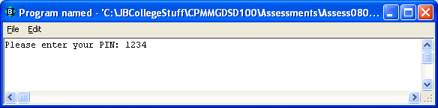

**The screen clears (don’t worry about this part for Java) and you are presented with the following menu options:**

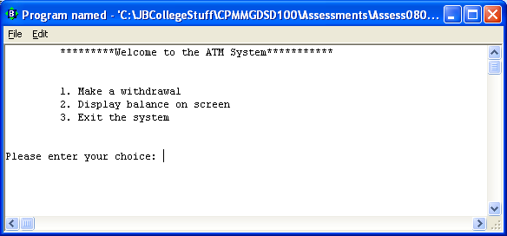

**Supplying an invalid PIN value:**

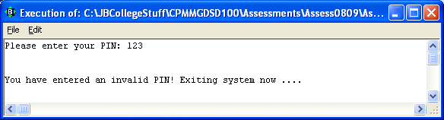

**Making a valid withdrawal:**

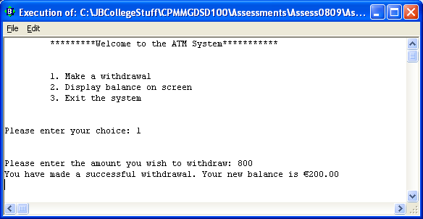

**Making an invalid withdrawal:**

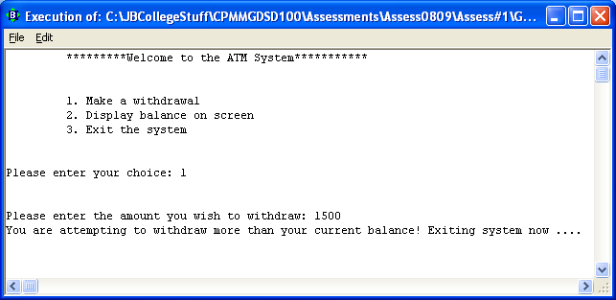

**Displaying the balance on screen:**

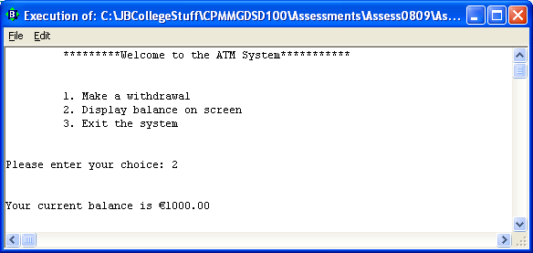

**Exiting the system:**

